**Mixins**

Definition of Mixin

-- A class that contains methods to be used by other classes without having to be the parent class of those other classes.

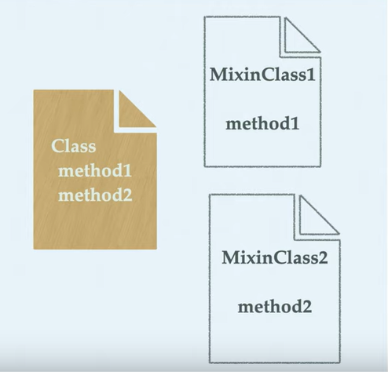

-- Mixins will always use the class.

-- Here we are going to use GenericAPIView which is the subclass of APIView. And we are going to use GenericAPIView for mixin.

-- Go to following link: <https://www.django-rest-framework.org/api-guide/generic-views/>

-- One of the big wins of using class-based views is that it allows us to easily compose reusable bits of behaviour.

-- those bits of common behaviour are implemented in REST framework’s mixin classes.

-- Note that mixin classes provide action methods rather than defining the handler method, such as get(), post(), directly. This allows for more flexible composition behaviour.

-- Mixin classes can be imported from rest_framework.mixins.

-- Following are the available mixins:

1. ListModelMixin

2. CreateModelMixin

3. RetrieveModelMixin

4. UpdateModelMixin

5. DestroyModelMixin